GoJupiter Project
Jupiter Travel Advisory Use-Case Model Survey

Abstract
This document provides an overview of the solution context, scope and high-level functional capabilities for the GoJupiter project. It catalogs the actors that interact with the system and the use cases that together describe all the ways in which they interact with the system. It also documents the use-case diagrams that show the relationships that exist between the actors and the use cases.

Version History
Date | Version | Author | Description
07/12/2015 | 0.1 | John Odlum  Dave Parham | Initial Edit
7/14/2015 | 0.2 | John Odlum  Dave Parham | Update of use case diagram and section 6, use case specification.


An Essential Unified Process Document
Table of Contents
1 Introduction 3
1.1 Document Purpose 3
1.2 Document Scope 3
1.3 Document Overview 3
2 Use-Case Diagrams 4
2.1 Review Attractions 4
3 Actor Catalog 4
4 Use-Case Catalog 5
5 Use case Specification x 6
5.1 Introduction 6
5.1.1 Document Purpose 6
5.1.2 Document Scope 6
5.1.3 Document Overview 6
5.2 Brief Description 7
5.3 Preconditions 7
5.4 Basic Flow 7
5.5 Alternative Flows 8
5.5.1 Write a Review 8
5.5.2 Non-Registered Travel Customer 8
5.6 Post-Conditions 9
5.7 Special Requirements 9
5.8 Extensibility 9
5.9 Scenarios 9
6 Use Case Specification 10

Introduction

Document Purpose
The purpose of this document is to provide an overview of the system use-case model in order to provide a high-level understanding of:
- Context – the people or things that interact with the system (the Actors)
- Scope – the things of value that the system performs for its Actors (the Use Cases).

Document Scope
The scope of this document is limited to:
- Diagramming and cataloging the system actors and use cases for the GoJupiter project.
The scope of this document does not include consideration of:
- Detailed specification of each use case – this is provided separately in a Use-Case Specification document for each use case.

Document Overview
This document contains the following sections:
- Brief Description – This use case provides the customer with a detailed overview how the GoJupiter.com review section will work. This use case will describe how a customer can read and write reviews for the attractions offered by GoJupiter.com
- Use-Case Model Overview – The review, use case diagram, shown in section 2.1 of this document, briefly outlines how the review process works for initial and return customers of GoJupiter.com.
- Actor Catalog – Section 3 of this document contains the catalog of all system actors for this use case.
- Use Case Catalog – Section 4 of this document contains the catalog of all system use-cases for GoJupiter.com.

- Use-Case Diagrams
This section provides an overview of the use-case model in the form of one or more use-case diagrams with supporting explanatory text.

Review Attractions
This use case describes how a GoJupiter.com visitor would read and write attraction reviews.
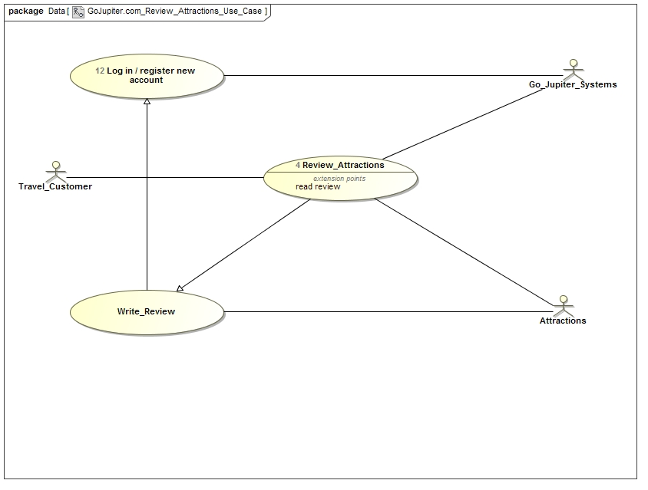
- Actor Catalog
The table below catalogs the system actors, specifying for each actor:
- Name – unique and meaningful name for the actor
- Brief Description – summarizing the role that the actor plays with respect to the system.
Name | Brief Description
Travel Customer | Individual interested in taking a trip to the planet Jupiter
GoJupiter System | Database system that facilitates the scheduling of travel, registration of customers, and reviews of attractions.
Attractions | Locations the travel customer can visit on the planet Jupiter
- Use-Case Catalog
The table below catalogs the system use cases, specifying for each use case:
- ID – unique identifier for the use case
- Name – unique and meaningful name for the use case
- Type:
  - Base – end-to end interaction between an actor and the system
  - Inclusion – abstracted common part of many Base Use Cases that is explicitly referenced by these use cases
  - Extension – extension of one or more referenced Base Use-Cases
  - Abstract – use case describing generic aspects of many Base Use Cases which in turn specialize this general case in some way.
- Brief Description – summarizes the use-case purpose in terms of the value produced for its actors and other stakeholders.
ID | Name | Type | Brief Description
001 | Book Flight | Base | Allows the travel customer to reserve a seat or multiple seats, if travelling with others, as well as a travel date to the planet Jupiter
002 | Review Attractions | Base | Provides the travel customer with feedback from previous customers about the travel destinations on Jupiter. Also will allow the returning travel customer to rate the attractions they visited on the planet.
003 | Register Customers | Base | Travel customers can register with GoJupiter.com to make booking future travel arrangements easier.

Use case Specification

One section per use cases – according to the use case specification template below

The <Use Case Name> Use-Case Specification specifies all requirements relating to this use case, including the flows through the use case and any non-functional requirements that relate specifically to this use case.

Introduction

Document Purpose
The primary objectives of the Use-Case Specification are to:
- Provide a complete set of requirements relating to the use case, including the flows through the use case and all significant external behavior of the use case
- Provide additional supporting information to support the communication of the purpose, requirements, constraints and flows through the use case.

Document Scope
The scope of this document is limited to consideration of:
- The specification this specific use case, including any non-functional requirements and constraints that relate specifically to this use case.
This scope of this document does not include consideration of:
- Requirements that relate specifically to any other use case – these are described in separate specifications for the other use cases
- Requirements that do not relate to any specific use case – these are described in a separate Supplementary Requirements document.

Document Overview
This document contains the following sections:
- Brief Description – focusing on the purpose of the use case
- Preconditions – the state the system must be in before the use case can performed
- Basic Flow – what normally happens when the use case is performed
- Alternative Flows – unusual, optional or exceptional use case behavior
- Post-Conditions –valid system states after the use case has finished
- Special Requirements – non-functional requirements that relate specifically to this use case
- Extensibility – where the use case can be extended by other use cases
- Scenarios – lists the key representative scenarios for this use-case
- Additional Information – any other useful supporting information
- References – provides full reference details for all documents, white papers and books that are referenced by this document.

Brief Description
This use case describes how a GoJupiter customer reads and writes a review for attractions on the planet Jupiter.

Preconditions
- The GoJupiter customer must have access to the Internet.
- The network connection to the GoJupiter System must be active.
- The GoJupiter customer needs to register at GoJupiter.com.

Basic Flow
{Access GoJupiter.com}
- The use case begins when the Travel Customer accesses GoJupiter.com
{Select Review Page}
- The Travel Customer selects the review drop down tab at the top of the page.
- The GoJupiter system goes to the review page.
{Select Attraction to Review}
- To read a review, the Travel Customer will select the attraction they are interested in reviewing.
- The GoJupiter system will return reviews made by previous customers in order of most recent review as well as the overall average star rating for that attraction.
- The Travel Customer can then look at reviews posted by previous travellers to that attraction.
{Return to Review Page}
- To return to the review page, the Travel Customer can either select the back button on their browser or select the return button on the bottom of the page.
{The Use Case Ends}
- The use case ends

Alternative Flows
This section describes the alternative flows for the use case, grouped into named subsections reflecting the area of functionality to which to the alternative flow relates. Each alternative flow is described in terms of:
- The point in the use case at which the alternative flow might begin
- The conditions under which the alternative flow will begin
- The flow of events within the alternative flow
- The point at which the use case resumes on completion of the alternative flow.

Write a Review

Handle the writing of a review

At {Select Attraction to Review} if Travel Customer wants to write a review:
- The Travel Customer will select the Write Review button.
- The GoJupiter system will direct the Travel Customer to the login page.
{Customer Login}
- The Travel Customer will enter their User ID.
- The Travel Customer will enter their Password.
- The GoJupiter system will validate the Travel Customer User ID and Password.
- The GoJupiter system will then direct the Travel Customer to the Write a Review Page.
{Write a Review}
- The Travel Customer will be given a dialog box to write their likes and dislikes about the attraction visited on Jupiter
- The Travel Customer will use a star rating option available for rating the attraction from 1 star, the lowest rating, to 5 stars, the highest rating.
- When the Travel Customer is finished with their review they can then select the submit button to add the review to the GoJupiter system for that attraction.
- Resume the use case from {Return to Review Page}

Non-Registered Travel Customer

Handle Non-Registered Travel Customers
At {Customer Login} if the Travel Customer is not a registered user of GoJupiter.com:
- The Travel Customer will select the Create Account button.
- The GoJupiter system will direct the Travel Customer to the Register Customer use case.
- Resume the use case from {Write a Review}

Post-Conditions
If a Travel Customer writes a review on an attraction then they will be able to see that review updated and displayed on the GoJupiter system.

Special Requirements

5.7.1 Data Security
Customer data will be encrypted inflight and at rest.

System Speed
System capacity is optimized for 50 concurrent users.
All website pages will render within 1 second of page load call.

Extensibility
No public extension points defined.

Scenarios
A scenario is an instance or specific occurrence of a use case. This section lists key representative scenarios for this use-case, listing for each scenario:
- Name – a unique and meaningful name for the scenario
- Flows Exercised – List of the use case flows exercised by the scenario
- Additional Notes – any supporting notes about the scenario or its purpose.
Name | Flows Exercised | Additional Notes
Review Attraction | 5.4
Read Reviews | 5.4
Write Reviews | 5.5.1
Non-Registered Travel Customer | 5.5.2 | User will have to follow the Register Customers use case.

Example of use case specification
This section provides any additional information required to make the use case more accessible to the stakeholders and the development team.
This template is an extended version of the original template defined by Cockburn [1], in particular extended with a possibility to describe Requested Information Resources often found useful when dealing with data oriented systems. [1] Cockburn, A. Writing Effective Use Cases. ISBN-13: 9780201702255. Addison-Wesley (2001).

Use Case Template | Description | Examples
Use Case Name | Name of the use case | Review Attractions
Use Case ID | Unique identifier of a use case | 002
Revision and Reference | Revision = version number of use case ID  Reference = URL of the use case (you get the URL by right-clicking on the entry in the index column) | V0.2
Use Case Diagram | Description of the UML use case diagram for the actual use case. The diagram should include extend and include relationships if there is any.  The actual UML diagram figure may be added at the bottom of the template by uploading a bitmap generated from a UML editor. | Use case diagram shows how the actor, Travel Customer, interacts with the GoJupiter system and the attractions to read and write reviews.
Status | Status of the use case development | One of the following:  in progress
Priority of accomplishment (optional) | The priority of the use case to be considered when assessing its importance for a development cycle. | One of the following:  Must have: The system must implement this goal/ assumption to be accepted.
Goal | Short description (max. 100 characters) of the goal to be achieved by a realization of the use case. | System stores attraction reviews/ ratings made by the Travel Customer for current/future GoJupiter.com Travel Customers. These reviews can help a Travel Customer make decisions about which attractions to see on the planet Jupiter.
Summary | Comprehensive textual description of the use case. | The travel customer will open the GoJupiter.com site and use the reviews button at the top of the page to navigate to the reviews page. Once at the reviews page, the travel customers will then select an attraction they wish to see previous customer reviews for. If the travel customer wishes to write a review for an attraction they have visited, then they need to log into the GoJupiter.com system and then write their review.
Category | Categorisation of use cases according to overall reference architecture. | Context dependent
Actor | List of users of the use case (actors) | Travel Customer  GoJupiter system  Attractions
Primary Actor (initiates) | Actor that initiates the use case execution. | Travel Customer
Stakeholder (optional) | Company, institution or interest group concerned by the execution of the use case | GoJupiter system  Attractions
Requested Information Resources  (optional) | Information category or object that is required to execute the use case or is being generated during the course of the use case execution.  The requested information resource shall be listed together with its requested access mode (create, read, update or delete) or “manage” which encompasses all access modes. | N/A
Preconditions | Description of the system/user status statement) that is required to start the execution of the use case.  Note that use cases can be linked to each other via "preconditions“. This means, a precondition for a use case can be either an external event or another use case. In this case the use case ID should be provided in the field „preconditions“. | The travel customer will need to login to the GoJupiter system in order to write reviews.
Triggers  (optional) | (External) event that leads to the execution of the use case.  Note that use cases can be linked to each other via "triggers“. This means, a trigger for a use case can be either an external event or another use case. In this case the use case ID should be provided in the field "triggers“. | Use case 003, register customers will have to be accomplished to write reviews.
Main success scenario | Numbered sequence of actions (use case workflow) to be carried out during the execution of the use case. | - Customer accesses the GoJupiter.com web site.  - Customer selects the review drop down menu at the top of the main page.  - GoJupiter system goes to the reviews page.  - Customer will select attraction they are interested in reviewing.  - GoJupiter system will return the reviews for the attraction in order of the most current review.  - Customer can browse the reviews written by previous customers.  - Customer can select the back button on the browser or return button at the bottom of the page to return to the GoJupiter.com main page.  - End use case
Extensions | Extension of an action of the main success scenario. The action to be extended shall be referred to by its number (e.g. 1) appended by a letter (e.g. 1a). | No Extensions
Alternative paths (optional) | Alternate path through the main success scenario w.r.t. an identified action. | 5.5.1. User can select to write a review on the attraction they are reviewing then return to the review page when they are complete.  5.5.2 Non-Registered users will need to go to the register customer use case to create a login ID and password. Then they will be returned to the write review path.
Post conditions | Description of the system/user status (statement) that holds true after the successful execution of the use case. | If the user writes a review then they will see that review added to the reviews for that attraction.
On Non-functional requirements | Description of non-functional requirements for this use case with respect to performance, security, quality of service or reliability. | N/A
Validation statement | List of statements that indicate how to validate the successful realization of the use case. | - Customer can read a review  - Customer can write a review and see it updated in the system.
Notes | Additional notes or comments (also by other users).
Author and date | Author of use case, date of last edition. | John Odlum and Dave Parham  14 Jul 2015

